**Bacon, Francis (1909 – 1992)**

The British painter Francis Bacon was one of the most important figures of international post-war modernism. During the 1940s and 1950s he developed a characteristic painting format that he used throughout his career, generally featuring an isolated figure within an armature or stage-like setting. Bacon’s work is renowned for its raw emotional appeal and also its ability to convey an existential sense of the human condition. Much of his early life was spent in Anglo-Irish houses near Dublin until, in 1926, his father expelled him from the family home. In 1927 he spent some time in Berlin, Paris and Chantilly; on returning to London Bacon set himself up as an interior decorator. His painting developed sporadically until *Three Studies for Figures at the Base of a Crucifixion* (1944)attracted considerable critical attention. During the 1950s a series of variations on Velazquez’s *Portrait of Pope Innocent X* (1650) supported the development of his international reputation, consolidated with a major retrospective at the Tate in 1962. In 1970, however, on the eve of his major retrospective exhibition at Grand Palais, Paris, his former lover George Dyer died of an overdose, a tragedy Bacon later commemorated in a group of triptychs. After this event he withdrew considerably from the Soho Bohemia in which he had played such a leading role during the previous two decades.

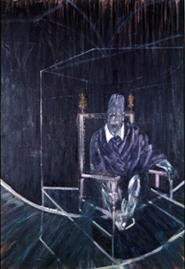

Francis Bacon *Pope II,* 1951

<http://www.francis-bacon.com/paintings/pope-ii-1951/?c=50-51>

By the late 1940s Bacon’s characteristic pictorial format had emerged: the single figure, frequently framed in a geometric armature against an indeterminate background. He also began the first of the series of paintings that featured throughout his career. This was a group of works focused around the screaming male figure: *Pope II*, for example, is part of the series embodying both his fascination with Velasquez’s *Portrait of Pope Innocent X* (c.1650) and the image of the screaming nurse from Eisenstein's film *Battleship Potemkin* (1925). These paintings have been interpreted as channeling a pre-occupation with violence, fuelled in part by the artist's fascination with sadomasochism but also by the turbulent experiences of his early life in post-independence Ireland. In a later interview with the art critic David Sylvester published in 1975 Bacon however denied any connection with any aspects of his personal life or wider experience: 'But this violence of my life, the violence which I’ve lived amongst, I think it's very different to the violence in painting. When talking about the violence of paint, it's nothing to do with the violence of war. It's to do with the attempt to remake the violence of reality itself'. The emotional intensity of these single figure studies has also invited readings in terms of both Cold War anxieties and existentialism.

Bacon’s work was usually focused around thematic series, including studies of animals in the late 1950s and portraits of a close circle of his friends, including Dyer, Lucien Freud and Henrietta Moraes executed in the 1960s. Rather than working directly from the figure Bacon now preferred to use photographs as a source, as in the series of portraits of the artist Isabel Rawsthorn painted between 1964 and 1970. Frequently, these photographs were provided for him by John Deakin, another member of the ‘Colony Club’ set. After George Dyer’s suicide, Bacon’s work became preoccupied with themes of death, loss and mourning, including a notable group of triptychs that act as a requiem for his former lover. These so-called ‘Black Triptychs’, in which the central motif of each panel is framed within a black doorway, use a format favoured by Bacon from the 1940s onwards and linked to his preoccupation with painting in series. *Triptych May-June 1973* depicts moments from Dyer’s progression towards death on his last evening; its compositional bleakness is also appropriate to the development of the artist’s late tragic theme.

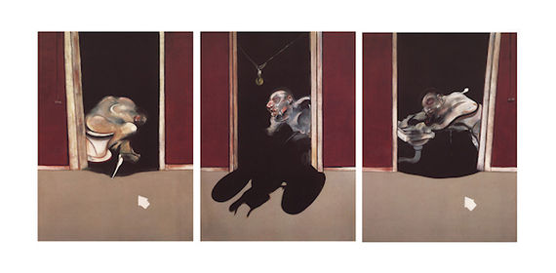

Francis Bacon *Triptych May-June 1973* <http://en.wikipedia.org/wiki/File:Triptych_May-June,_1973.jpg>

**References and further reading**

Russell, J. (1993) *Francis Bacon*, London: Thames and Hudson. A useful introduction to Bacon’s art and his ideas about painting.

Peppiatt, M. (2008) *Francis Bacon: Anatomy of an Enigma*, London: Orion Books. Revised edition (original 1996) of authoritative biography incorporating both archival research and fascinating personal recollection.

Sylvester, D. (1987, 3rd ed.) *The Brutality of Fact:* *Interviews with Francis Bacon,* London: Thames and Hudson. Important source material for information on Bacon’s own views of the development of his work.

Cappock, M (2007) *Francis Bacon’s Studio,* London: Merrell Publishers. An account of the reconstructed studio at Dublin City Gallery the Hugh Lane by its curator, documenting both the move from London and the thousands of objects, including unfinished paintings, found in the studio

The Estate of Francis Bacon <http://www.francis-bacon.com/> official website of the Bacon estate